**Unit-4 Kurose 6th chapter**

* Identify various elements of wireless networks. (6.1)
* List two key characteristics of the more popular wireless network standards. (6.1)
* R1. What does it mean for a wireless network to be operating in “infrastructure mode?” If the network is not in infrastructure mode, what mode of operation is it in, and what is the difference between that mode of operation and infrastructure mode?

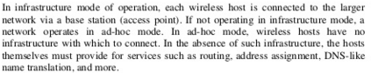

* R2. What are the four types of wireless networks identified in our taxonomy in Section 6.1? Which of these types of wireless networks have you used?



* Compare and contrast the characteristics of three 802.11 standards used for wireless LAN technology. (6.3)
* Explain the principal components of the 802.11 wireless LAN architecture. (6.3.1)
* R5. Describe the role of the beacon frames in 802.11.



* Describe how a wireless station associate with an AP before it can send or receive network-layer data in 802.11. (6.3.1)
* Compare and contrast Active and passive scanning for access points. (6.3.1)
* how do wireless stations seamlessly move from one BSS to another while maintaining ongoing TCP sessions? (6.3.4)
* Section 6.3.4 discusses 802.11 mobility, in which a wireless station moves from one BSS to another within the same subnet. When the APs are interconnected with a switch, an AP may need to send a frame with a spoofed MAC address to get the switch to forward the frame properly. Why?

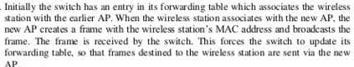

* Discuss two advanced capabilities found in 802.11 networks. (6.3.5.)